Guidance to the use of the paradigm

The entire guidance serves as a help for you and must of course be removed so as not to appear in the completed document.

* Red text is a guidance for you.

It can be deleted when you are ready. The red text MUST be deleted, at the latest, when completing the document.

* Black text on white background is standard text.

As a general rule, this text should NOT be deleted or changed. However, you have to delete it, if a section or a text is not at all relevant for your tender.

* Text being highlighted in turquoise: Text with a turquoise background is optional and/or must be edited. If the text is inserted into [square brackets], the text must not be edited, but simply be selected on or off. If the text is inserted into <angle brackets>, it must be rephrased.

In order to make the work as easy for you as possible and ensure that the finished document is without faults, you should proceed in this order:

1. Read this guidance every time, even if you think you remember its content.
2. Activate the review function in Word and adjust the settings so as to hide any changes, leaving only the final document visible. The changes can always be retrieved, if you need it.
3. Delete the text in the document that are not relevant to your document.
4. Consider the red text.
5. Add text if required.
6. Delete red text when you are sure that you have understood the guidance. You can make the text visible again as long as you have not "accepted" the changes in Word.
7. Read the document carefully. Does it all make sense?
8. Update details in the header to the actual date, administrative officer, document number etc.
9. Make sure the document is quality assured and make any changes.
10. “Accept all changes” and remove the turquoise background colour. Update table of contents if needed. Disable the track changes function.

Paradigm

Health and Safety Plan – HSP

**Major construction projects and capital preservation maintenance**

Section <designation>  
Stage <number and designation>  
Contract <number and designation>

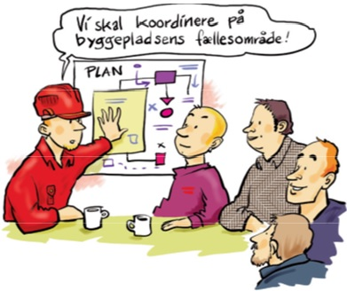

|  |  |  |
| --- | --- | --- |
| **Rev. No.** | **Date** | **Remarks** |
| <Rev. No.> | <Date> | <Name/company> |
|  |  |  |
|  |  |  |
|  |  |  |
|  |  |  |
|  |  |  |

**Table of Contents**

1. The actual contract 4

2. General 4

3. Time schedule – special conditions, hazardous and particularly hazardous work 6

4. The Health and Safety organisation of the workplace 6

5. Construction site layout 7

6. Common areas and movements in connection with these 7

7. Areas with several employers 8

8. Common safety measures 8

9. Inspection of installations and safety measures 9

10. Hazardous and particularly hazardous work 9

11. Contingency Plan of the construction site 10

12. Coordinating meetings on safety 11

13. Accidents and near incidents 12

14. Special conditions and measures 13

15. Updating 13

16. Authorities 13

Document management 13

**Appendices**

Sheets and revision list

Appendix 1: Time schedule

Appendix 2: Organisational chart

Appendix 3: Description of work processes

Appendix 4: Construction site layout

Appendix 5: Distribution of responsibility within common areas

Appendix 6: Hazardous and particularly hazardous work

Appendix 7: Work specifications

Appendix 8: Contingency plan for the construction site

Appendices 9-19: Appendices available

**Image source:** Images have kindly been lent to us by BAR Bygge og Anlæg.

# The actual contract

The contract is to be briefly described, and below is a guidance to the contents:

<Brief description of the contract:

What is to be build/constructed, what does it comprise?

Period for the building/construction work

Time limits – any references to descriptions in other tender documents

Indication of any neighbouring contracts

Indication of common area with other contracts, e.g. a signs subcontract under an earthworks and drainage contract

Common areas, including interfaces with traffic and other clients etc.

Subcontracts, main or design-build contracts>

This describes in general terms specific health and safety points of observation.

<Identification of special utilities including e.g. gas and high voltage lines

Traffic/track

Special chemical risks

Work at sea

Requirements for introduction to safety

Other>

Class 3 safety clothing, hard hat and safety footwear are required.

Here, further requirements for safety clothing are to be stated

# General

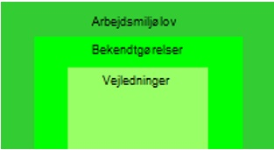The present Plan for Health and Safety (HSP) applies to planning and coordination of health and safety work and is based on:

* The current legislation on health and safety – including [Bygherrens pligter](https://at.dk/regler/bekendtgoerelser/bygherrens-pligter-117/)
* The Danish Road Directorate’s [health and safety policy](https://www.vejdirektoratet.dk/sektion/om-os#2) is   
    
  available at the Danish Directorate’s homepage vd.dk.
* Project material of the contracts

The Client is responsible for ensuring that the AMK-B (health and safety coordinator for execution) coordinates and defines safety and health in the workplace and the work area.

The Client is responsible for ensuring that the HSP conforms with actual conditions and agreements on layout of the construction site and applicable common safety provisions.

The Contractor to the Danish Road Directorate is responsible for obtaining material and/or information to be inserted in the HSP for its own works and on behalf of any subcontractors and suppliers, including for giving notice of any changes to the coordinator, and to update its own contributions.

Contractors are therefore responsible for maintaining their respective contributions to the HSP and for giving notice of any changes to the Client’s AMK-B.

Contractors are therefore responsible for maintaining their respective contributions to the HSP as well as for giving notice of any changes to the coordinator

The HSP shall be available to all employees at the workplace.

Each employer (contractors, suppliers, etc.) is responsible for ensuring that those employed on the contract have received instructions in relation to the contents of the health and safety plan, are familiar with its content and know where the plan can be found. Each individual employer shall instruct its employees in relation to the agreements which apply to cooperation with other companies on the construction site.

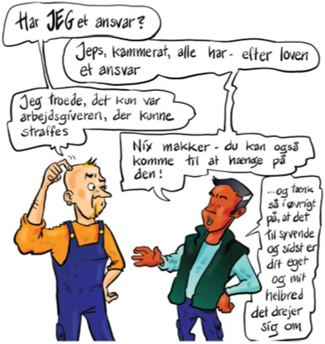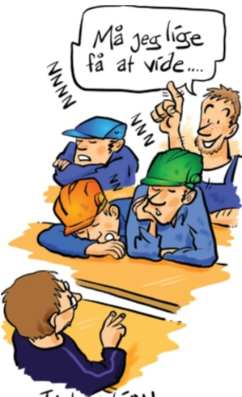

The Danish Working Environment Authority requires employers (contractors, subcontractors, suppliers, etc.) to ensure that each individual employee, regardless of the type of employment and duration, receives sufficient and suitable training and instructions to carry out the work in a safe manner. Information shall be provided on any accident and health risks involved in the work, including occupational medicine studies to which the employees have access.

Current versions of the HSP and their appendices shall be noted in the revision list and, if necessary, in the minutes of the coordinating safety meeting.

The minutes from coordinating safety meetings/on site-meetings is part of the HSP.

# Time schedule – special conditions, hazardous and particularly hazardous work

In this project the concept <”working schedule or design and execution schedule”> is to be used instead of ”time schedule” (The Danish Working Environment Authority uses the concept time schedule), by which there is correspondence with the concepts of the AB system.

Guidance: In technical and main contracts the concept work schedule is to be used. In design-build contracts the concept design and execution schedule is to be used, cf. the AB system.

The schedules current at any time: <”working schedule or design and execution schedule”> have been entered as Appendix 1. It specifies the individual work stages as well as during which periods particularly hazardous work shall be carried out.

The contractors prepare <”working schedule or design and execution schedule”> for their respective tasks. These shall be coordinated with regard to particularly hazardous work at safety meetings (or site meetings). The level of detail shall allow the Client's health and safety coordinator to assess whether the project can actually be carried out under safe and healthy conditions, including when there will be common work areas.

<”Working schedule or Design and Execution schedule”> shall be dealt with for the next 4 – 6 weeks. Which employers, including number of employees as well as the person responsible for the work, are expected during the execution of the individual activity, is to be stated under the activities. They shall also specify whether there shall be any "Particularly Hazardous Work".

Contractors shall forward a draft at least 3 working days before each coordinating safety meeting.

# The Health and Safety organisation of the workplace

Appendix 2, Organisational Chart, shows the employers represented (contractors, subcontractors and suppliers) on a given contract, as well as information on concurrent contracts/utility owners etc.

Contacts in the workplace health and safety organisation can be found in the Workplace Address List in Appendix 3, which contains contact details, companies and function, etc.

All employers, including foreman and health and safety representative according to the health and safety organisation, have a duty to participate at the coordinating safety meetings. Those attending the meeting must be authorised to make binding agreements regarding health and safety work on the worksite.

The AMK-B coordinates the health and safety work in the common areas of the construction site on behalf of the Danish Road Directorate.

The HSP prepared during the design phase is revised by the AMK-B with input from the Contractor.

The construction site is notified by the AMK-B, unless otherwise agreed with the Danish Road Directorate's Contract Manager.

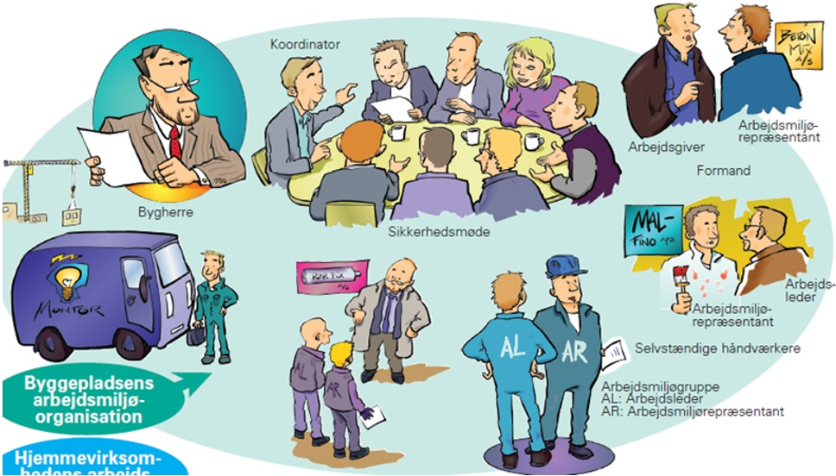

# Construction site layout

Site layout, including workplaces, work areas and set down areas etc. include all compulsorily acquired, temporarily acquired areas, the Danish Road Directorate's own areas as well as borrowed and/or leased areas.

In principle, the Client considers the entire area used for construction/site activations as a common area, as several actors can be expected in the area. The AMK-B can waive or modify this approach in cooperation with contractors and the Danish Road Directorate's supervisory management.

For a detailed description of the scope of the boundaries, layout and content of the construction site, see Appendix 4.

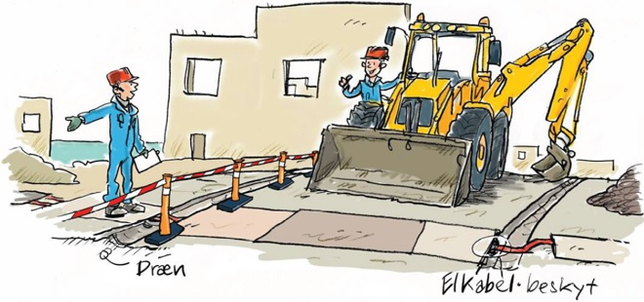

# Common areas and movements in connection with these

Appendix 5 shows who is responsible for the installation, maintenance, adaptation and dismantling of safety measures in the common areas. The site layout drawing, Appendix 4, provides details of access roads.

Coordinating safety meetings will address rules for traffic in and around common areas, including signs, restrictions, separate walking and vehicle routes, evacuation routes, access for emergency vehicles, etc. The rules will be determined by the AMK-B in consultation with the contractors and recorded in the minutes of the coordinating safety meetings.

# Areas with several employers

Indication of areas where several employers work simultaneously is to be described and coordinated at the coordinating safety meetings. Detailed information can be read in the minutes of the latest meeting.



# Common safety measures

The individual contractors' current areas of responsibility in relation to safety measures in common areas are specified in Appendix 5, which will be updated regularly by the AMK-B.

On a regular basis, the AMK-B will ensure the definition of who is responsible for establishing, adapting, maintaining and dismantling necessary common safety, health and welfare measures.

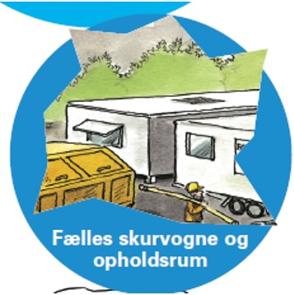Contractors are obliged to install, adapt, maintain and, at the time agreed at the coordination safety meetings, to dismantle and remove any measure. This is to advance the health and safety of workers and is necessary for employees of contractors and subcontractors at the workplace.

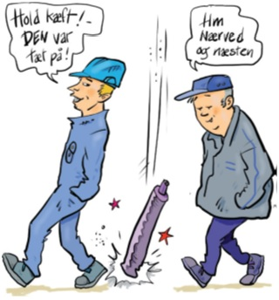

# Inspection of installations and safety measures

Procedure for ongoing checks of installations and safety measures is specified in Appendix 5.

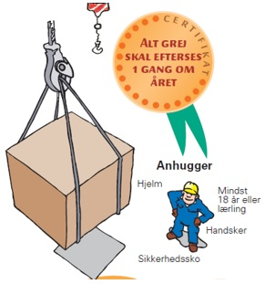

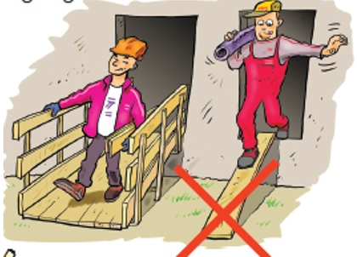

# Hazardous and particularly hazardous work

Areas where the work involves particular risks are listed in Appendix 6. This list is compiled during the design phase and will be updated during the construction phase.

The Contractor is to draft a work process description for each job (work procedure/basic WA/special WA). The prepared work process descriptions shall be forwarded to the AMK-B with a deadline as specified in the tender documents. The work specification is to be entered into the HSP, in Appendix 7. In respect of health and safety, the work process description can be replaced by a workplace assessment (WA), which meets current legislation. It is important that all employees on site receive instructions.

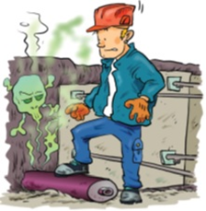 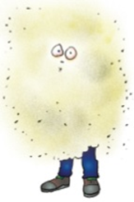 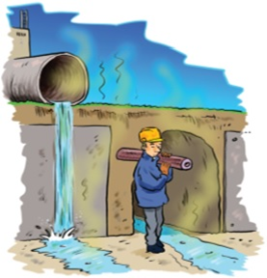

Sewage

Dust

Contaminated soil

Delimitation of hazardous work and particularly hazardous work is to be discussed at coordinating safety meetings.

Each Contractor shall ensure that a chemical risk assessment has been carried out for work processes involving hazardous chemical substances and materials (hazardous chemicals). Training and instruction adapted to the individual work situations and employees shall be ensured.

The Contractor shall submit documentation on chemical risk assessment of the work processes and safety data sheets.

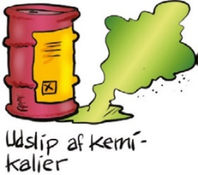  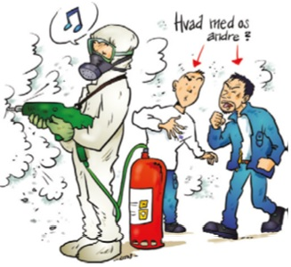

# Contingency Plan of the construction site

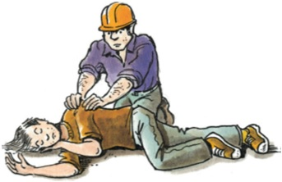

Contingency plan for the construction site is found in Appendix 8. The plan is prepared by the Client's AMK-P (health and safety coordinator during the design phase) and updated regularly by the AMK-B. All employers shall be familiar with the Construction Site Plan.

Definitions:

* Contingency plan for the construction site is common to all actors on the construction site.   
  If the project involves particularly complex issues in terms of rescue, the site contingency plan can be supplemented with a Part 2 on rescue.
* The Contractor's contingency plan (cf. SWS Management and Cooperation) is specific to the work of the Contractor and is targeted at the Contractor's employer responsibilities. The Contractor's contingency plan will be appended to the site contingency plan in the HSP.

The design phase

The AMK-P will prepare a **site contingency plan** in cooperation with the designers.

The construction phase:

The AMK-B will follow up on the site contingency plan in the HSP, which is prepared during the design phase.

The Contractor is responsible for the preparation and updating of its own contingency plan and for its contribution to the site’s contingency plan in the HSP.

The AMK-B will incorporate contributions from contractors' contingency plans into the Site Contingency Plan.

Each contractor shall draw up an contingency plan for its own works. (cf. requirements for the Contractor's contingency plans in Management and Cooperation) and shall, e.g., describe rescue measures in connection with the execution of "particularly hazardous work" (cf. HSP Appendix 6).

The site contingency plan is to be posted in a visible place on the site.

Alarm, fire, rescue and first aid equipment and location of escape routes are specified by the AMK-B in cooperation with the Contractor on the site layout, Appendix 4.

Plans for contingency, evacuation and drill shall be described in the Contractor's contingency plan, if relevant. This may, i.a., be relevant in connection with particularly hazardous work or if, in any other way, there is a particular risk of an emission of hazardous substances, particular danger of fire, explosion, accidents or the like. It shall also be stated who is in charge of the ongoing control and coordination of the various plans.

# Coordinating meetings on safety

At the request of the AMK-B, the Contractor (represented employers on the building/ construction site) shall participate in health and safety coordination meetings.

Coordinating health and safety meetings shall be held at least every two weeks, and all employers (contractors, subcontractors, suppliers, contractors working on other contracts, other clients, etc.) with activities on the construction site in the coming period must participate in the meeting when summoned by the AMK-B.

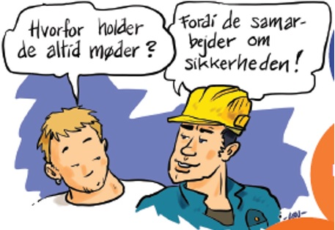

The AMK-B convenes extraordinary safety meetings in the event of accidents and near-accidents, if deemed appropriate. In addition, extraordinary safety meetings will be convened for bridge castings. Furthermore, it can be valuable to hold multi-discipline safety meetings, e.g. when several contractors border or work in the same area.

For contracts with more than 10 employees, coordination of safety takes place at the coordinating safety meetings and for contracts with 10 or fewer employees, coordination of safety takes place at site or coordinating safety meetings.

For contractors with fewer than 5 employees on the site, the foreman shall participate.

For contractors with 5 or more employees on the site, both the foreman and the health and safety representative shall participate.

The AMK-B can choose to hold coordinating safety meetings on construction sites where there are fewer than 10 workers.

Contractors/subcontractors shall follow the AMK-B's instructions on construction site safety and health.

AMK-B prepares and submits the minutes of the coordinating safety meetings.

**Initial meetings**:

It is a legal requirement to hold start-up meetings on large construction sites where there are more than 10 employees on site at the same time.

However, the AMK-B can choose to hold start-up meetings on sites where there are fewer than 10 employees for complex projects.

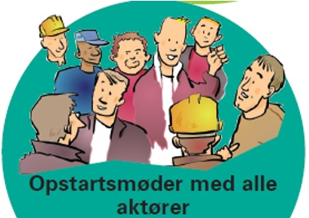

For the holding of Health and Safety Start-Up Meeting, refer to the paradigm for “Health and Safety Start-Up Meeting”.

New contractors/subcontractors joining during the construction phase shall attend a start-up meeting with the AMK-B to be briefed on site conditions before work on site starts. Contractors are obliged to inform the AMK-B of the arrival of subcontractors, suppliers and other partners on the project so that a start-up meeting can be convened.

Arrangement of regular start-up meetings is to be notified at coordinating safety meetings and minuted.

The Contractor shall ensure that its own employees, as well as subcontractors and suppliers, who move around the construction site, are given the A5 leaflet "Information Leaflet on Health and Safety (construction site)" if the AMK-B deems it advantageous to use it.

Rounds:

Safety inspection rounds shall be carried out at least once a fortnight. The AMK-B will decide which members of the health and safety organisation will participate in the inspection rounds. The minutes of coordinating safety meetings will state who shall participate in the next inspection round.

Following each inspection round, the AMK-B will fill out an inspection round form according to the principles for a model workplace. Checklists documenting the review are to be sent to the participants of the inspection round and others.

If the Danish Road Directorate introduces a digital inspection round app, it shall be used instead of the printed form.

# Accidents and near incidents

In the event of accidents or near-accidents, the AMK-B and the Danish Road Directorate's supervisors shall be informed immediately. For serious accidents and near-accidents outside normal working hours, the Danish Road Directorate's Project Manager, Area Manager or Press Officer shall be contacted. The AMK-B shall be called, in case the Danish Working Environment Authority turns up on the construction site in order to investigate the industrial accident.

In case of accidents, all contacts from the media shall be made to the Danish Road Directorate's Communications Manager.

All Contractors/subcontractors and suppliers at the workplace shall record and analyse accidents and near incidents. Registration and analysis shall be carried out within the Danish Road Directorate’s digital tool, SafetyNet. Contractors shall initiate short and long-term preventive actions. Contractors shall initiate short and long-term preventive actions.

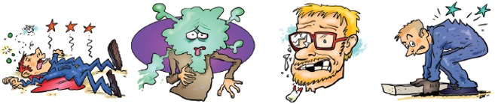

Contractors/subcontractors shall also provide details of accidents and near-accidents at coordinating safety meetings that have occurred in the period since the last meeting.

# Special conditions and measures

Particularly hazardous works are listed in Appendix 6, and specific measures are specified in Appendix 7 of the execution and handling of such works.

# Updating

The systematic follow-up on the construction site of health and safety conditions, including the HSP and related appendixes, will take place at safety meetings, where upcoming tasks will also be coordinated.

The AMK-B is responsible for regular updating of the HSP.

# Authorities

When receiving visits from or being in contact with the Danish Working Environment Authority or other authorities, the AMK-B shall be notified immediately.

# Document management

The item Document management is to be removed when using this paradigm

|  |  |  |  |  |  |  |
| --- | --- | --- | --- | --- | --- | --- |
| Approved by | Unit/Network | Subject in QMS | Next revision | Access | Case No. | Author |
| KIR  /DT-TES-TBOA  18-10-2022 | Health and Safety subject to the Client’s responsibility? | Contract Management -> Common to contracts – Health and safety during execution | 31-10-2025 | Internal  External | 13/19170-6 | ARS et al. /DT-TES-TBOA |

Re. the paradigm: Document management of Appendices follows the main document.

|  |
| --- |
| *Definition: A paradigm is a document/template with a set of pre-formatted information and editable fields that make it easier to produce the final document.* |